# Experiment No: 6

# Title: Hydraulic and Pneumatic Testing of Hydraulic and Pneumatic circuits /Applications

**Date: 7 October 2021**

**Name: Shaunak Deshpande**

**Class: TY IC-C**

**Roll number: 39**

**GR Number: 11911180**

**Q.1) Design an electro-pneumatic circuit such that a single acting cylinder will advance upon pressing an  
electrical push button "START" and will retract upon releasing it.  
(Use a 3/2 solenoid actuated spring returned control valve)**

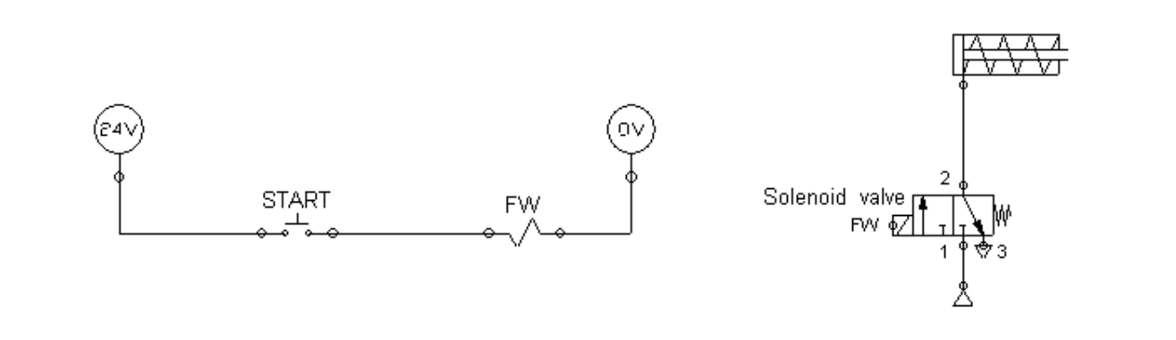

**Answer:**

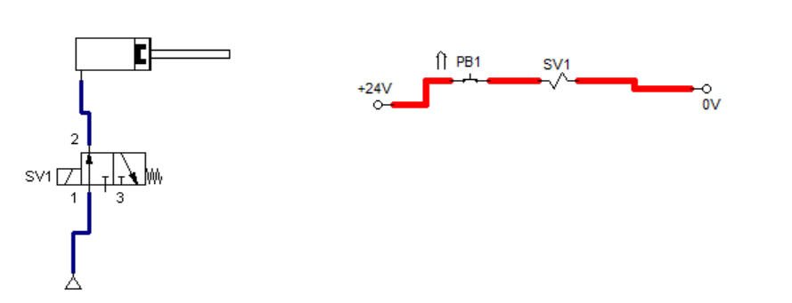

#### **Q.2) Double acting cylinder is used to perform machine operation. Pneumatic cylinder is advanced by pressing two push buttons simultaneously. If any one of the push button is released, cylinder comes back to start position. Draw the pneumatic circuit, PLC wiring diagram and ladder diagram to implement this task.**

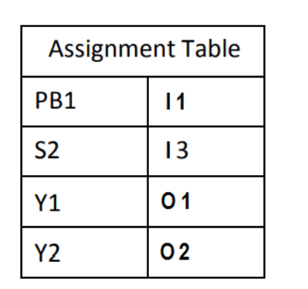

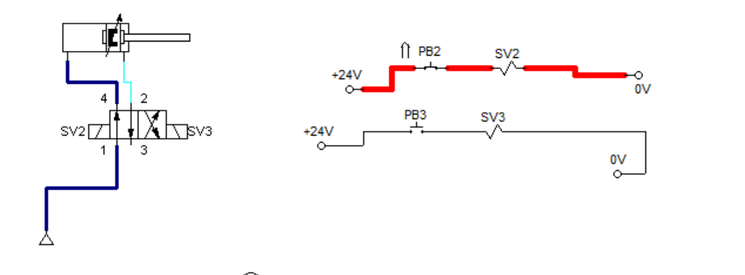

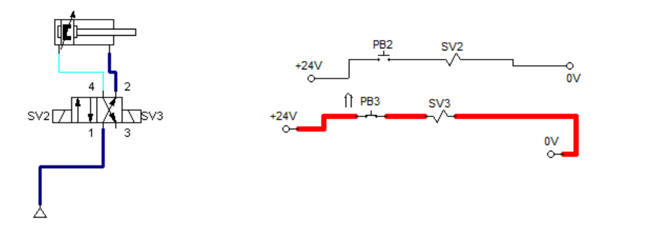

#### **Q.3) Double acting cylinder is used to perform pressing operation. Cylinder has to move forward when PB1 button is pressed and return for set time of 20 seconds before it automatically returns to the initial position. Limit switch S2 is used for end sensing of the forward motion of the cylinder. Draw the pneumatic circuit, PLC wiring diagram and ladder diagram to implement this task.**

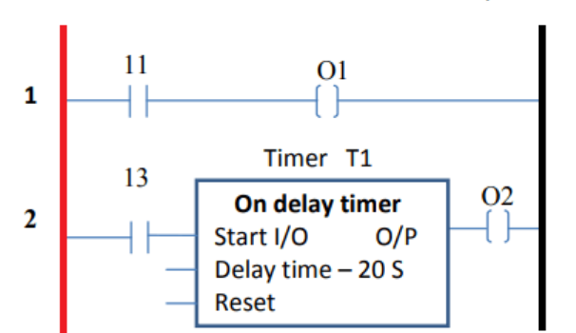

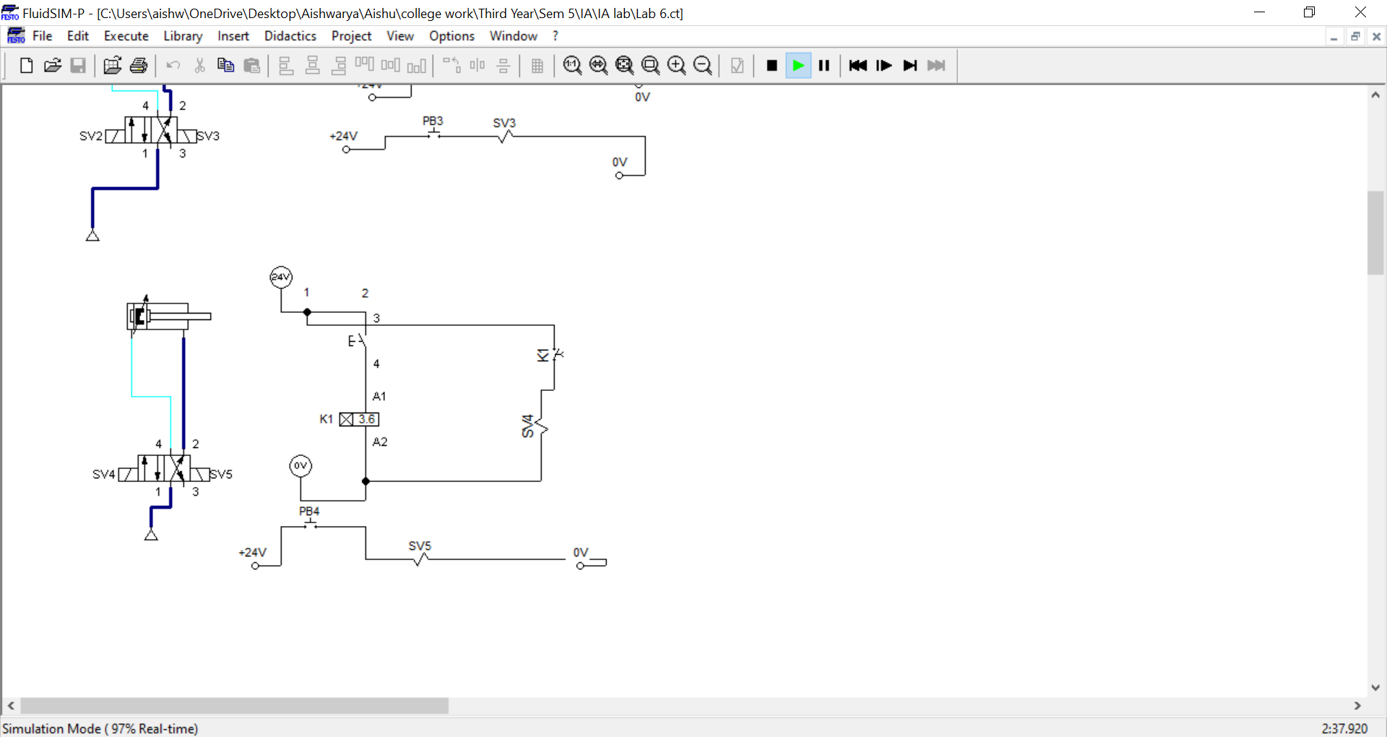

**Conclusion:-**

* We learned to perform pneumatic and hydraulic application through this lab.
* We also learned to perform the electro-pneumatic circuit.
* We understood the concept/implementation of electro-pneumatic circuit and also learned how to integrate hydraulic and pneumatic applications together.